PROJECT REPORT

Smart Traffic Management System Using Arduino, RFID & IR Sensors

1. ABSTRACT
Traffic congestion and delayed emergency response are major challenges in urban environments. This project presents a Smart Traffic Management System that dynamically controls traffic signals based on real-time traffic density and provides priority passage to emergency vehicles using RFID technology. The system uses IR sensors to detect vehicle density and an RFID module to override traffic signals when authorized emergency vehicles are detected. Implemented on an Arduino UNO, the system operates in real time using a non-blocking finite state machine, ensuring high accuracy, responsiveness, and scalability for smart city applications.

2. INTRODUCTION
Traditional traffic lights operate on fixed timers, which leads to inefficiencies during low or high traffic conditions and delays emergency vehicles. With the rise of smart cities, there is a need for adaptive, intelligent, and low-cost traffic control systems.
This project proposes a cost-effective smart traffic signal system that:
- Adjusts signal timing automatically based on traffic density
- Prioritizes emergency vehicles
- Works in real time with minimal hardware
- Can be extended to multi-junction systems

3. PROBLEM STATEMENT
- Fixed-time traffic lights waste green time when no vehicles are present
- Emergency vehicles are delayed in traffic congestion
- Existing intelligent systems are expensive and complex

4. OBJECTIVES
- Design an adaptive traffic signal controller
- Detect traffic density using IR sensors
- Implement emergency vehicle priority using RFID
- Develop a non-blocking real-time control algorithm
- Ensure system scalability and reliability

5. SCOPE OF THE PROJECT
- Single-lane intersection (prototype level)
- Emergency vehicle identification via RFID
- Real-time traffic adjustment
- Offline operation (no internet dependency)
Future scope includes:
- Multi-way intersections
- Camera-based AI detection
- IoT cloud integration
- Government smart city deployment

6. SYSTEM REQUIREMENTS

6.1 Hardware Requirements
Component | Quantity
Arduino UNO | 1
IR Sensors | 2
RFID RC522 | 1
RFID Tags | 1–2
LEDs (Red, Yellow, Green) | 3
Resistors | 3
Jumper Wires | As required

6.2 Software Requirements
- Arduino IDE
- MFRC522 RFID Library
- Embedded C/C++

7. SYSTEM ARCHITECTURE

📊 Block Diagram (Explain in Viva)
IR Sensor 1 ─┐
├──> Arduino UNO ───> Traffic LEDs
IR Sensor 2 ─┘ │
└──> RFID Reader (Emergency Override)

Description:
- IR sensors send traffic density data
- Arduino processes inputs using FSM logic
- RFID overrides traffic logic when emergency vehicle is detected
- LEDs act as traffic signals

8. WORKING METHODOLOGY

Step-by-Step Operation
- System initializes in RED signal state
- IR sensors continuously monitor traffic
- Green time is calculated dynamically
- RFID is checked continuously (highest priority)
- Emergency vehicle → Immediate GREEN
- System returns to normal operation

9. FLOWCHART
START
↓
Initialize System
↓
Check RFID?
├─ YES → GREEN (Priority Mode)
└─ NO
↓
Read IR Sensors
↓
Calculate Traffic Density
↓
Set Green Time
↓
GREEN → YELLOW → RED
↓
LOOP

10. ALGORITHM
- Initialize I/O pins and RFID module
- Set default traffic signal to RED
- Continuously monitor RFID reader
- If emergency RFID detected:
  - Override signals
  - Set GREEN for fixed priority time
- Else:
  - Read IR sensor values
  - Determine traffic density
  - Allocate green signal duration
- Repeat loop continuously

11. IMPLEMENTATION DETAILS

Key Techniques Used
- Finite State Machine (FSM)
- Non-blocking timing using millis()
- Interrupt-like priority handling
- Modular function-based design
This ensures:
- High responsiveness
- Accurate timing
- No system freezing
- Professional-grade logic

12. RESULTS & OUTPUT
- Successfully detects traffic density
- Dynamically adjusts signal timing
- Emergency vehicle gets instant clearance
- Stable and accurate real-time operation

13. ADVANTAGES
- Low cost
- Real-time operation
- Emergency-friendly
- Scalable architecture
- Smart city compatible

14. LIMITATIONS
- Prototype-level (single direction)
- IR sensors affected by environment
- RFID range is limited

15. FUTURE ENHANCEMENTS
- AI camera-based vehicle detection
- Multi-junction synchronization
- GSM/IoT monitoring
- Mobile app integration
- Government traffic analytics

16. APPLICATIONS
- Smart cities
- Hospitals & emergency routes
- School zones
- Industrial traffic control
- Defense and secure areas

17. CONCLUSION
The proposed Smart Traffic Management System effectively improves traffic flow and emergency response using adaptive control and priority-based signaling. The system demonstrates how embedded intelligence can significantly enhance urban traffic efficiency using low-cost hardware.

18. REFERENCES
- Arduino Official Documentation
- MFRC522 RFID Library
- IEEE Smart Traffic Systems Research Papers
- Smart City Traffic Management Studies

🔌 ARDUINO PIN CONFIGURATION

LEDs
Signal | Pin
Red | 8
Yellow | 9
Green | 10

IR Sensors
Sensor | Pin
IR1 | 2
IR2 | 3

RFID RC522
RC522 | Arduino
SDA | 7
SCK | 13
MOSI | 11
MISO | 12
RST | 6
3.3V | 3.3V
GND | GND
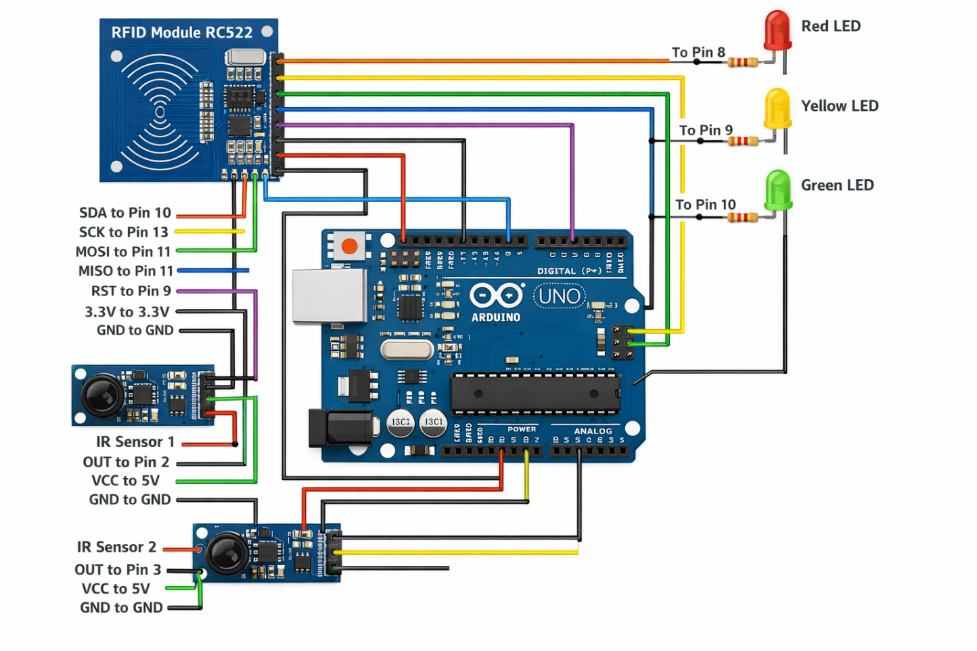

🎯 What makes it “smart” (not basic)?
Your system will:
- Detect traffic density using 2 IR sensors
- Adjust green light timing dynamically (more cars → longer green)
- Give priority using RFID (ambulance, police, VIP lane)
- Fallback to normal mode when no traffic is detected
This is competition-ready and interview-friendly.

🧠 System Logic (High Level)

1️⃣ Traffic Density Detection (IR Sensors)
- IR Sensor 1 (Near signal) → detects queue start
- IR Sensor 2 (Far from signal) → detects long queue
IR1 | IR2 | Traffic Level | Green Time
0 | 0 | No traffic | 10 sec
1 | 0 | Low traffic | 20 sec
1 | 1 | High traffic | 40 sec

2️⃣ RFID Priority Override 🚑
If a registered RFID tag is detected:
- Immediately switch GREEN
- Hold green for fixed priority time
- Ignore IR sensors during this time
Use case:
- Ambulance
- Fire truck
- Government vehicle

3️⃣ LED Signal Control
You’ll simulate one junction:
- 🔴 Red
- 🟡 Yellow
- 🟢 Green

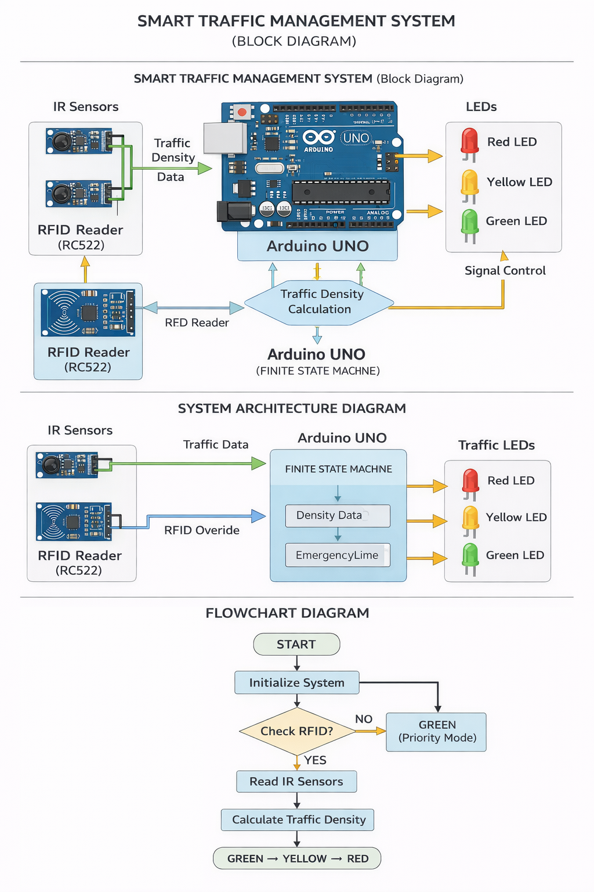
CODE:
#include <SPI.h>
#include <MFRC522.h>

/* ---------- PIN DEFINITIONS ---------- */
#define RED_LED 8
#define YELLOW_LED 9
#define GREEN_LED 10

#define IR1_PIN 2
#define IR2_PIN 3

#define SS_PIN 7
#define RST_PIN 6

MFRC522 rfid(SS_PIN, RST_PIN);

/* ---------- TIMING (ms) ---------- */
#define YELLOW_TIME 3000
#define RED_TIME 10000
#define RFID_GREEN 30000

#define GREEN_LOW 10000
#define GREEN_MEDIUM 20000
#define GREEN_HIGH 40000

/* ---------- STATE MACHINE ---------- */
enum TrafficState {
RED,
GREEN,
YELLOW,
RFID_MODE
};

TrafficState currentState = RED;
unsigned long stateStartTime = 0;
unsigned long greenDuration = GREEN_LOW;

/* ---------- EMERGENCY RFID UID ---------- */
byte emergencyUID[4] = {0x63, 0xF0, 0x0A, 0x0E}; // CHANGE THIS

/* ---------- FUNCTION DECLARATIONS ---------- */
void setRed();
void setYellow();
void setGreen();
bool checkRFID();
void updateTrafficDensity();

void setup() {
Serial.begin(9600);

pinMode(RED_LED, OUTPUT);
pinMode(YELLOW_LED, OUTPUT);
pinMode(GREEN_LED, OUTPUT);

pinMode(IR1_PIN, INPUT);
pinMode(IR2_PIN, INPUT);

SPI.begin();
rfid.PCD_Init();

setRed();
stateStartTime = millis();

Serial.println("Smart Traffic System Initialized");
}

void loop() {

/* ---------- RFID HAS HIGHEST PRIORITY ---------- */
if (checkRFID()) {
currentState = RFID_MODE;
stateStartTime = millis();
setGreen();
Serial.println("RFID PRIORITY MODE");
}

unsigned long currentMillis = millis();

switch (currentState) {

case RED:
if (currentMillis - stateStartTime >= RED_TIME) {
updateTrafficDensity();
currentState = GREEN;
stateStartTime = currentMillis;
setGreen();
}
break;

case GREEN:
if (currentMillis - stateStartTime >= greenDuration) {
currentState = YELLOW;
stateStartTime = currentMillis;
setYellow();
}
break;

case YELLOW:
if (currentMillis - stateStartTime >= YELLOW_TIME) {
currentState = RED;
stateStartTime = currentMillis;
setRed();
}
break;

case RFID_MODE:
if (currentMillis - stateStartTime >= RFID_GREEN) {
currentState = RED;
stateStartTime = currentMillis;
setRed();
Serial.println("RFID MODE ENDED");
}
break;
}
}

/* ---------- FUNCTIONS ---------- */

void updateTrafficDensity() {
int ir1 = digitalRead(IR1_PIN);
int ir2 = digitalRead(IR2_PIN);

if (ir1 == HIGH && ir2 == HIGH) {
greenDuration = GREEN_LOW;
Serial.println("Traffic: NONE");
}
else if (ir1 == HIGH && ir2 == LOW) {
greenDuration = GREEN_MEDIUM;
Serial.println("Traffic: LOW");
}
else if (ir1 == LOW && ir2 == HIGH) {
greenDuration = GREEN_MEDIUM;
Serial.println("Traffic: LOW");
}
else {
greenDuration = GREEN_HIGH;
Serial.println("Traffic: HIGH");
}
}

bool checkRFID() {
if (!rfid.PICC_IsNewCardPresent()) return false;
if (!rfid.PICC_ReadCardSerial()) return false;

for (byte i = 0; i < 4; i++) {
if (rfid.uid.uidByte[i] != emergencyUID[i]) {
rfid.PICC_HaltA();
rfid.PCD_StopCrypto1();
return false;
}
}

rfid.PICC_HaltA();
rfid.PCD_StopCrypto1();
return true;
}

/* ---------- LED CONTROL ---------- */

void setRed() {
digitalWrite(RED_LED, HIGH);
digitalWrite(YELLOW_LED, LOW);
digitalWrite(GREEN_LED, LOW);
}

void setYellow() {
digitalWrite(RED_LED, LOW);
digitalWrite(YELLOW_LED, HIGH);
digitalWrite(GREEN_LED, LOW);
}

void setGreen() {
digitalWrite(RED_LED, LOW);
digitalWrite(YELLOW_LED, LOW);
digitalWrite(GREEN_LED, HIGH);
}

……………………………..

